Midterm Exam -- II
CMPSC 623: Analysis of Algorithms
Fall 2007
Dr. Honggang Zhang

Instructions:

- Put your name and student number on the exam paper NOW!
- The exam is closed book and closed notes.
- You have 75 minutes to complete the exam. Be a smart exam taker - if you get stuck on one problem go on to another problem. Also, don't waste your time giving irrelevant (or not requested) details.
- The total number of points for each question is given in parenthesis. There are 100 points total.
- Show all your work. Partial credit is possible for an answer, but only if you show the intermediate steps in obtaining the answer.
- You will be graded not only on the correctness of your answer, but also on the clarity with which you express it. Be neat.
- Good luck.

Problem | Points | Grade
1 | 25
2 | 25
3 | 25
4 | 25
Total | 100

Name:____________________________________________________

Problem 1: (25 points)

1. Hash Functions.
a. Consider a hash function h: h(k)=k mod m. Why is it not a good idea to pick m=2^p, where p is some positive integer?
b. Consider another hash function h: h(k) = ⎣ m ( kA- ⎣kA⎦ )⎦, where m=2^3, A = .1011 (this is a binary number). Compute h(k) if k=1101 (a binary number).

2. Consider a hash function h that can uniformly at random distribute n keys into a hash table with m slots. Answer the following questions:
a. If we pick up a key x, what is the expected number of keys that have the same hash value as x?
b. Consider all keys altogether, what is the expected number of collisions?

Problem 2: (25 points)
Consider the activity selection problem discussed in class. The problem is described as follows. Suppose we have a set of S={a₁, a₂, …, a_{n}} of n activities that wish to use a common resource, which can only be used by one activity at a time. Each activity i has a start time s_{i} and finish time f_{i}. If selected, activity a_{i} takes place during half-open time interval [s_{i}, f_{i} ). Activities a_{i} and a_{j} are compatible if the intervals [s_{i}, f_{i}) and [s_{j}, f_{j}) do not overlap. The activity selection problem is to select a max-size subset of mutually compatible activities.
a. Professor Smith comes up with an algorithm to solve this problem. His idea is a greedy strategy: make a sequence of choices, at each step, always select the activity of least duration from those that are compatible with previously selected activities.
Can this algorithm always solve the activity selection problem? Why or why not?

b. He also comes up with another greedy algorithm: always select the earliest start time activity that is compatible with previously selected activities.
Can this algorithm always solve the activity selection problem? Why or why not?

(Hint, in order to show an algorithm is correct, you need to give a complete proof. If you want to prove an algorithm is incorrect, you can simply give a counter example.)

Problem 3: (25 points)

Suppose you are given two sets A and B, each containing n positive integers. Inside each set, you can re-order items in whatever order you like. After reordering, let a_{i} be the i-th element of set A, and let b_{i} be the i-th element of set B. You then receive a payoff of 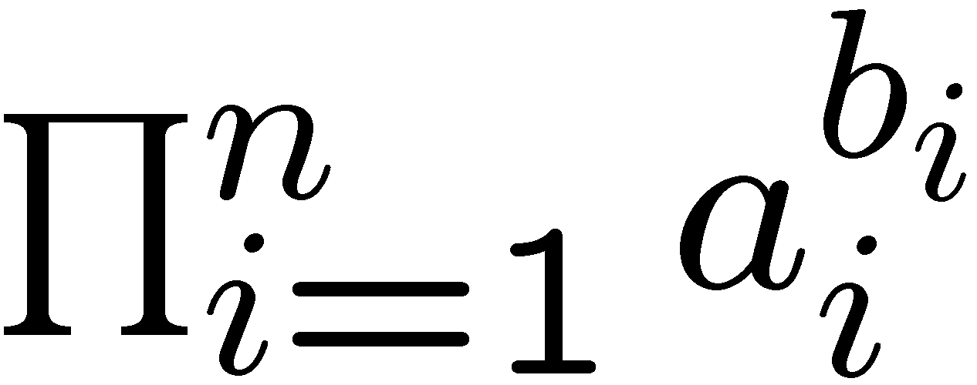 .
a. Give a greedy algorithm (pseudo code) that will maximize your payoff.
b. Prove that your algorithm maximizes the payoff. The key part is that you need to prove this problem has greedy choice property.
c. Analyze its running time.
(Note, in your pseudo code, if you use a function discussed in class as a subroutine, you can simply call it without giving details about how it works.)

Problem 4: (25 points)

Give an O(n²)-time dynamic programming algorithm to find the longest monotonically increasing subsequence of a sequence of n numbers.
Please write your pseudo code clearly, give a short description of how it works, and give a short and clear analysis of the running time of your algorithm.
(Hint: recall that a subsequence is not necessarily contiguous. For example, for a sequence <3, 2, 4, 1, 6, 8>, one monotonically increasing subsequence is <2, 4, 8>. The longest monotonically increasing subsequence is <3, 4, 6, 8> or <2, 4, 6, 8>)

